Terraform Task -02

Task Title
Execute all the templates shown in the video.
Objective
To create a local file using Terraform, manage values using variables, generate a random pet name using the random provider, and understand Terraform lifecycle commands such as init, plan, and apply.
Prerequisites
- Terraform installed on the system
- Visual Studio Code installed
- Basic understanding of Terraform concepts
- Internet access to download Terraform providers
Step 1: Create Terraform Project Directory
- Created a folder named terraform basic
- Opened the folder in Visual Studio Code
- Created the following files:
  - main.tf
  - variables.tf (created later)
Step 2: Initial Terraform Configuration
Created main.tf with a simple local provider and local file resource.
provider "local" {
}

resource "local_file" "sample_file" {
filename = "jenkins-terraform.txt"
content = "Terraform integrated with Jenkins"
}
Purpose:
To verify Terraform setup and create a file locally.
Step 3: Initialize Terraform
Executed the following command in terminal:
terraform init
What happened:
- Terraform initialized the backend
- Downloaded the local provider
- Created .terraform directory and .terraform.lock.hcl
Result:
Terraform initialization completed successfully.
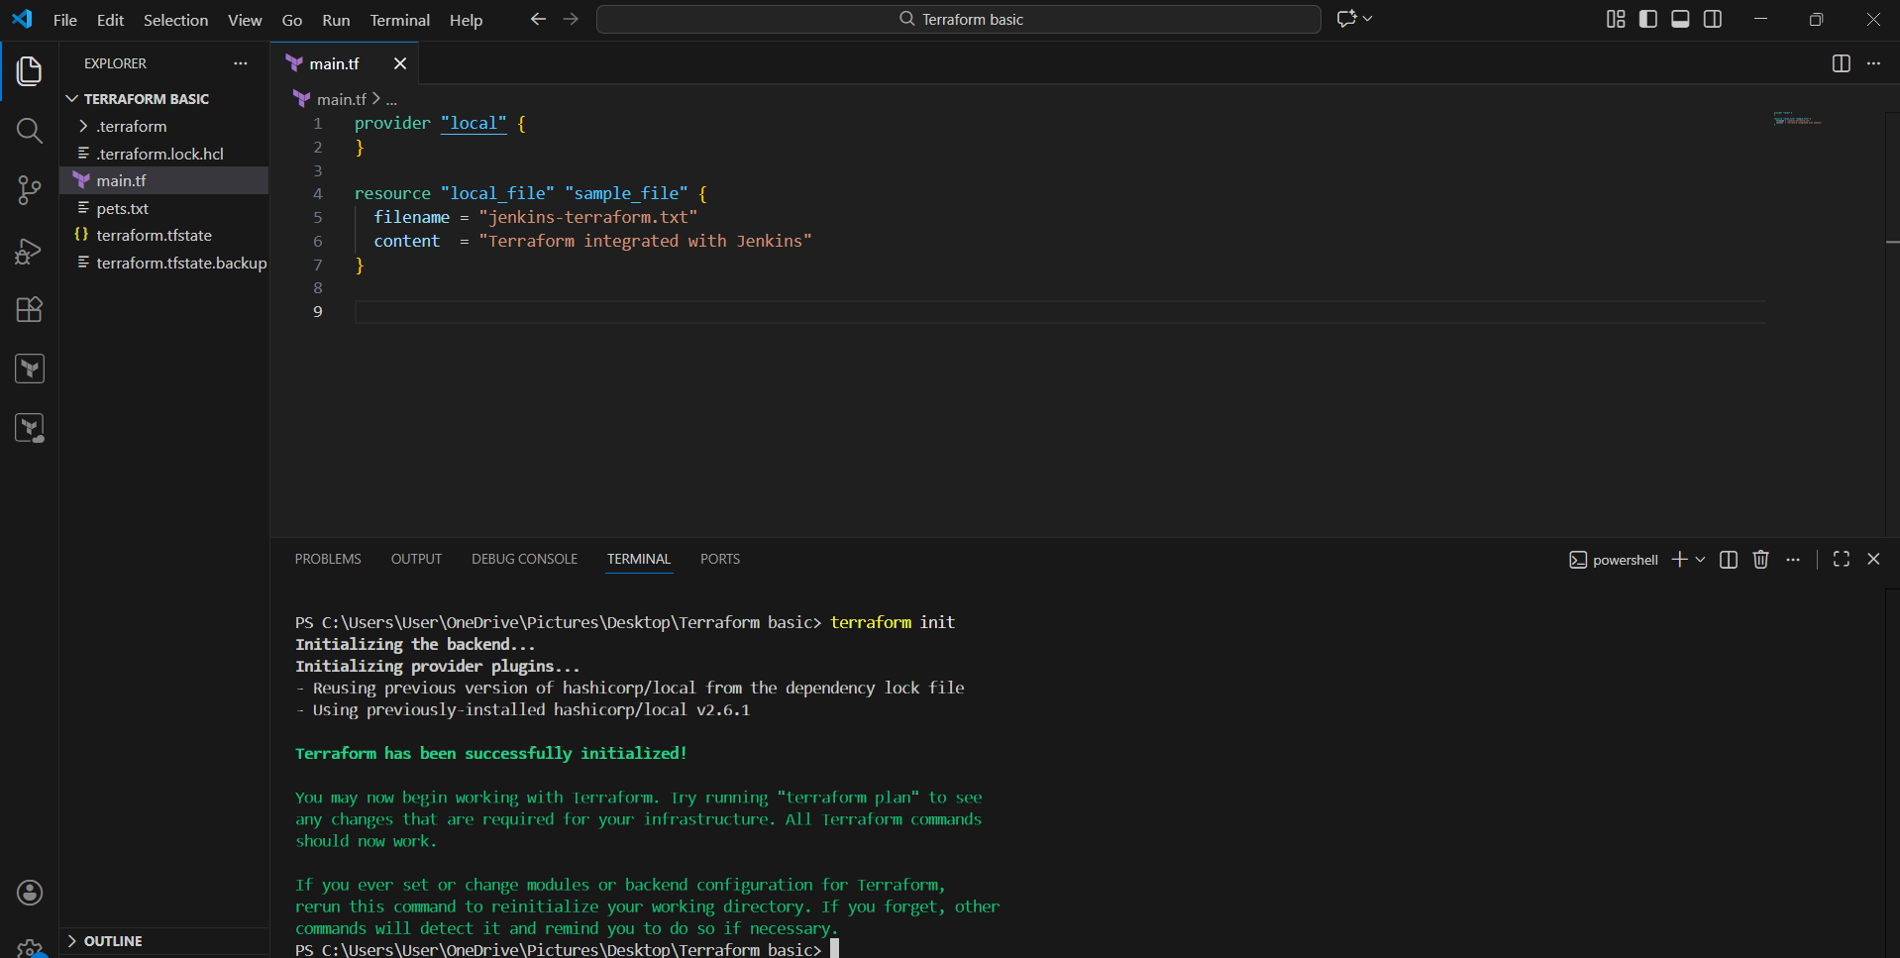
Step 4: Created Variables File
Created variables.tf to avoid hardcoding values.
variable "filename" {
description = "Name of the file to be created"
type = string
default = "pets.txt"
}

variable "content" {
description = "Content to be written into the file"
type = string
default = "My pet name will be generated by Terraform"
}
Purpose:
To make the Terraform configuration reusable and dynamic.
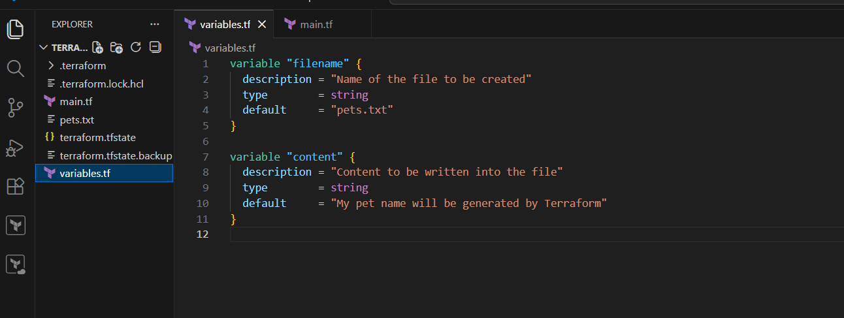
Step 5: Updated main.tf to Use Variables
Modified main.tf to use variables.
resource "local_file" "my_pet" {
filename = var.filename
content = var.content
}
Step 6: Added Random Pet Resource
Added a random provider resource to generate a pet name.
resource "random_pet" "petname" {
prefix = "MR"
separator = "-"
length = 1
}
Purpose:
To generate a dynamic value using Terraform.
Step 7: Re-initialize Terraform
Ran the initialization command again:
terraform init
What happened:
- Terraform detected a new provider
- Downloaded the random provider
- Updated provider lock file
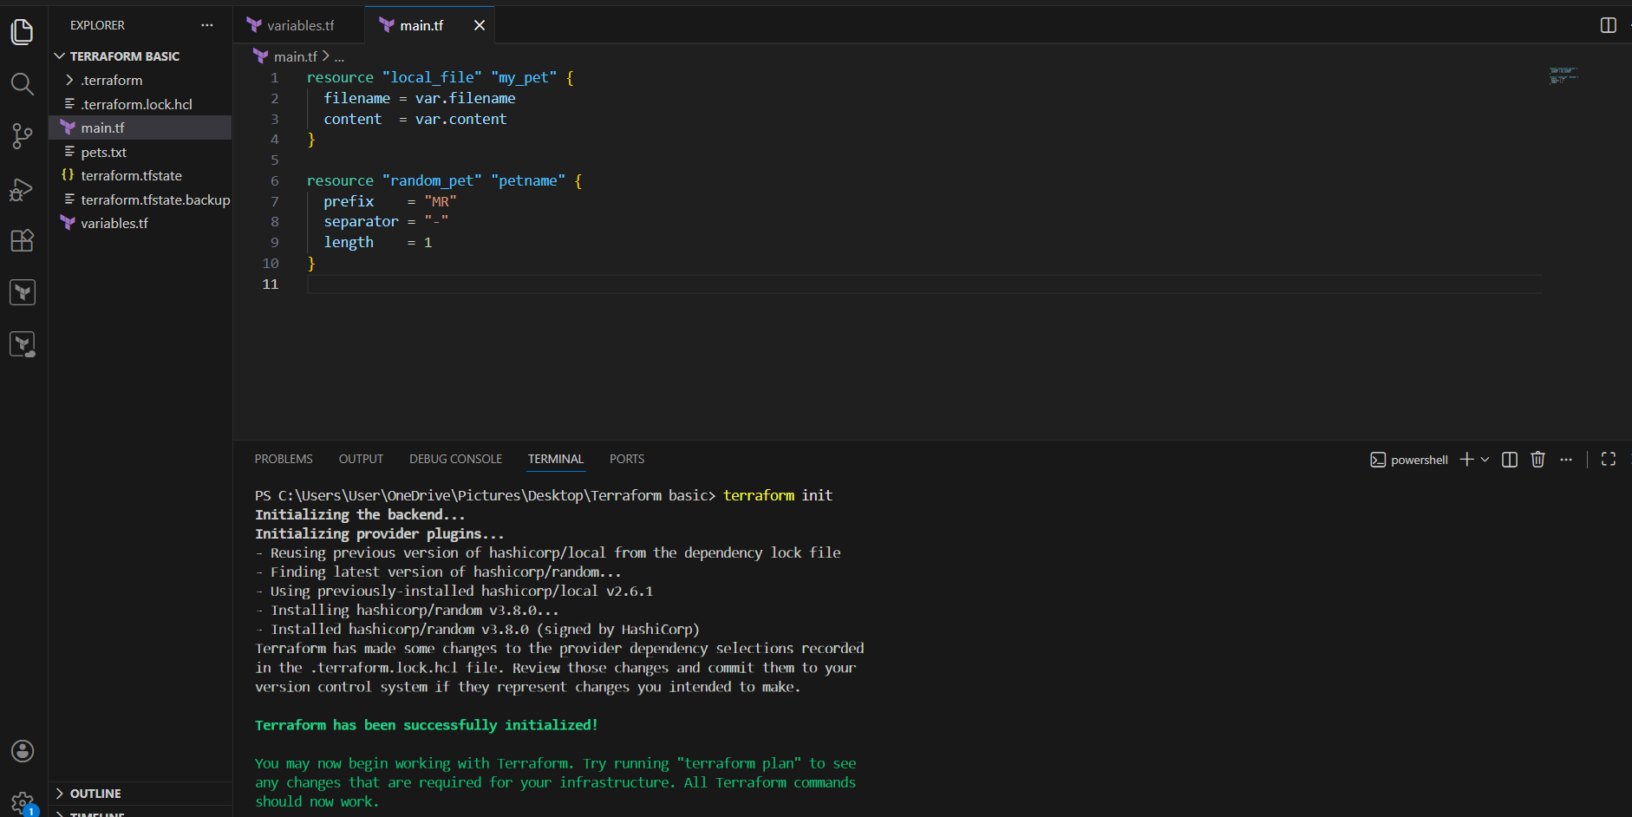
Step 8: Terraform Plan Execution
Executed:
terraform plan
Observation:
- Terraform compared current state with desired configuration
- Detected:
  - Local file must be replaced
  - Random pet resource will be created
Plan Summary:
Plan: 2 to add, 0 to change, 1 to destroy
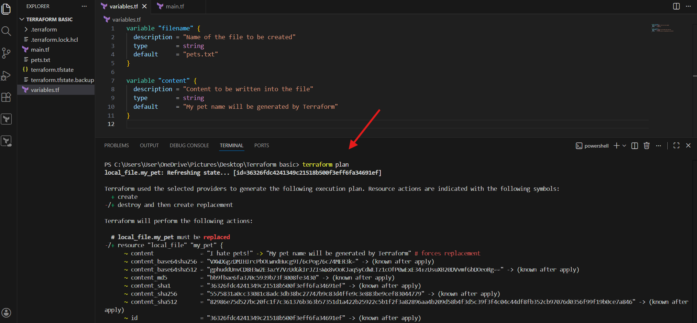
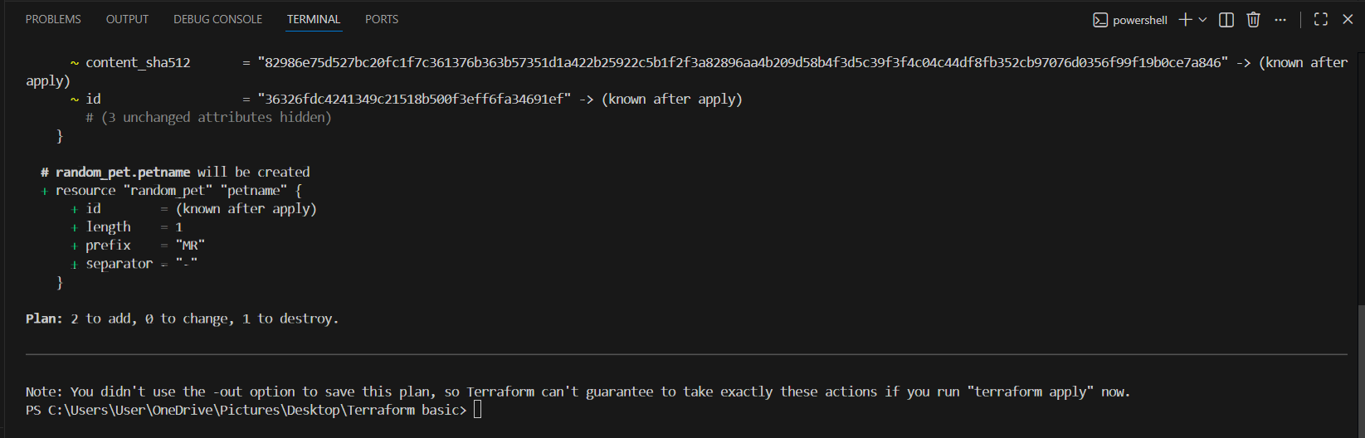
Step 9: Terraform Apply Execution
Executed:
terraform apply
- Entered yes when prompted
Terraform Actions:
- Destroyed old local file
- Created random pet resource
- Created new local file
Result:
Apply complete! Resources: 2 added, 0 changed, 1 destroyed
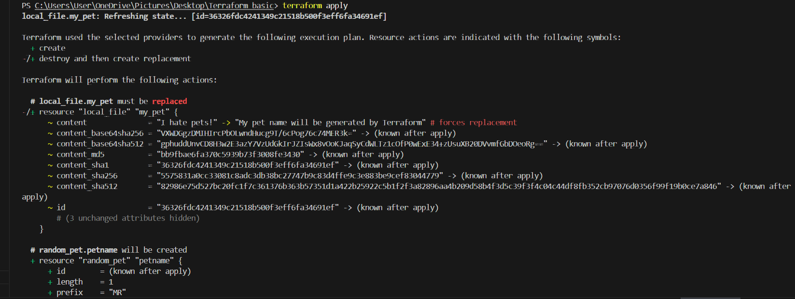
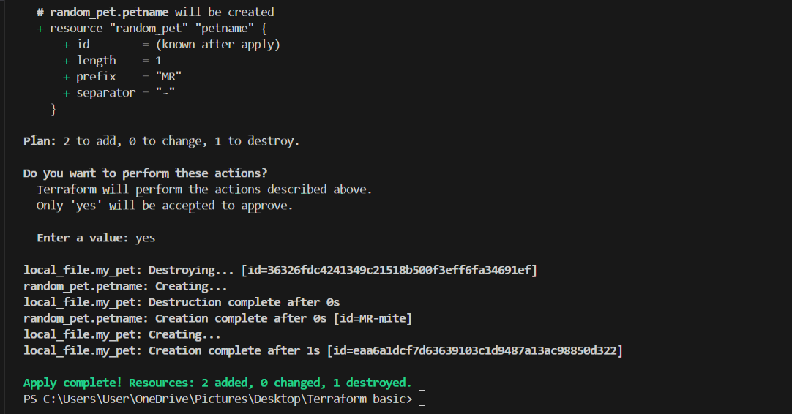
Step 10: Output Verification
- File pets.txt was created successfully
- Content inside the file:
My pet name will be generated by Terraform
Step 11: Terraform State Verification
- Opened terraform.tfstate file
- Verified:
  - Resource details
  - Generated random pet ID (example: MR-mite)
  - Filename and content stored in state
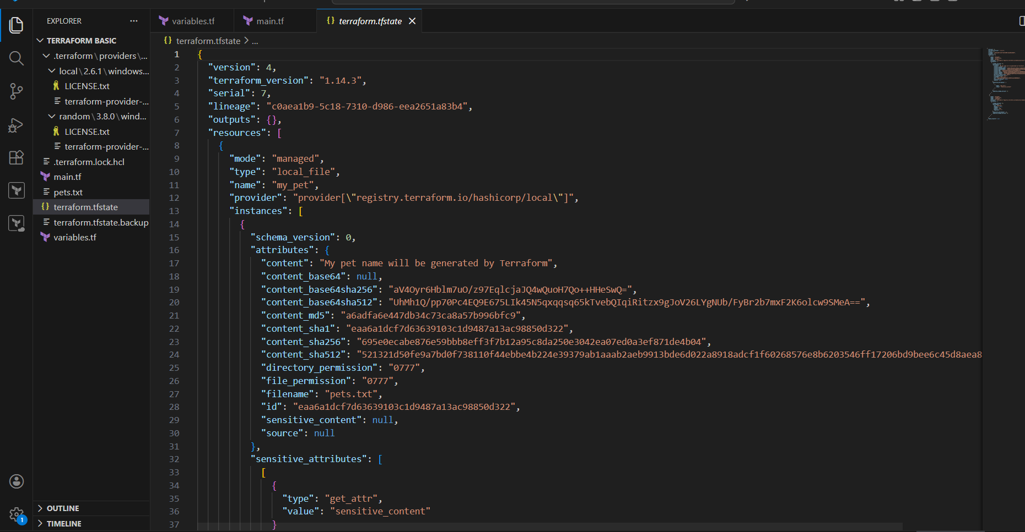
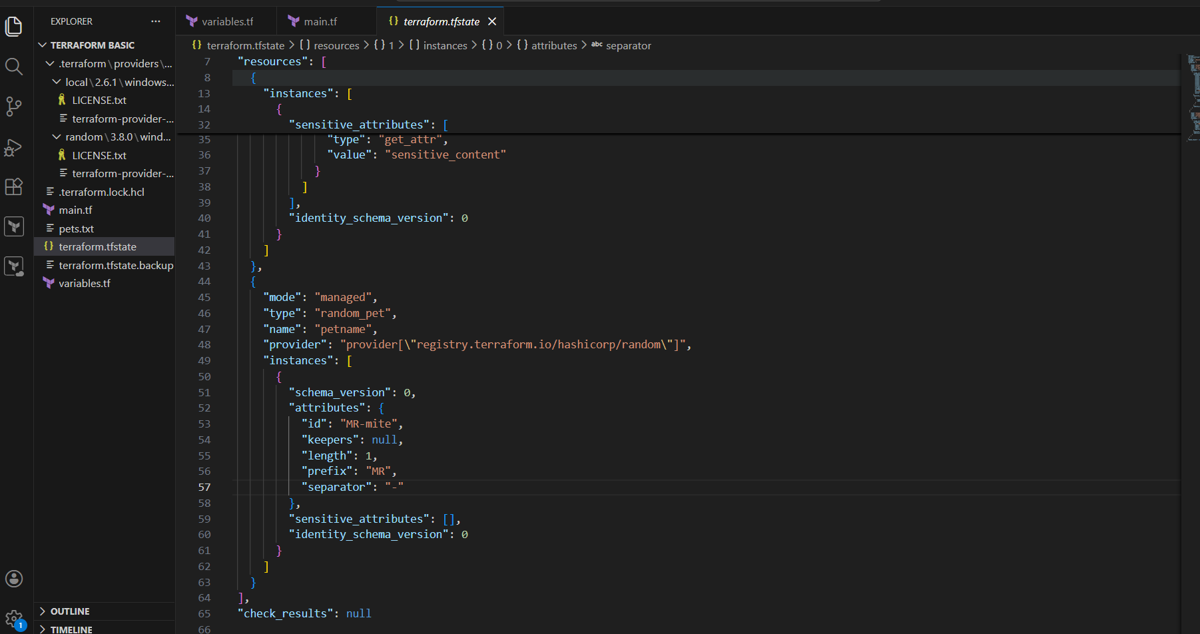
Step 13: Updated File Content (For Replacement Test)
User modified the content in main.tf:
resource "local_file" "pet" {
filename = "pets.txt"
content = "we love dogs!"
}
Observation
- Content change triggered resource replacement
- Terraform destroyed the old file and created a new one
Result
Apply complete! Resources: 2 added, 0 changed, 1 destroyed
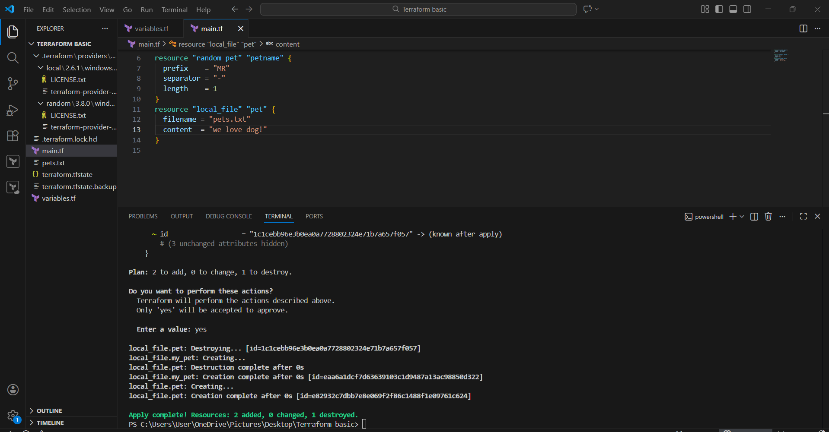
Step 14: Used create_before_destroy
User updated main.tf to avoid file deletion before recreation.
resource "local_file" "pet" {
filename = "pets.txt"
content = "we love domestic & animals!"

lifecycle {
create_before_destroy = true
}
}
Purpose
- Ensure new resource is created before destroying the old one
- Prevent temporary file loss
Terraform Behavior
- New file created first
- Old file destroyed after creation
Result
Apply complete! Resources: 2 added, 0 changed, 1 destroyed
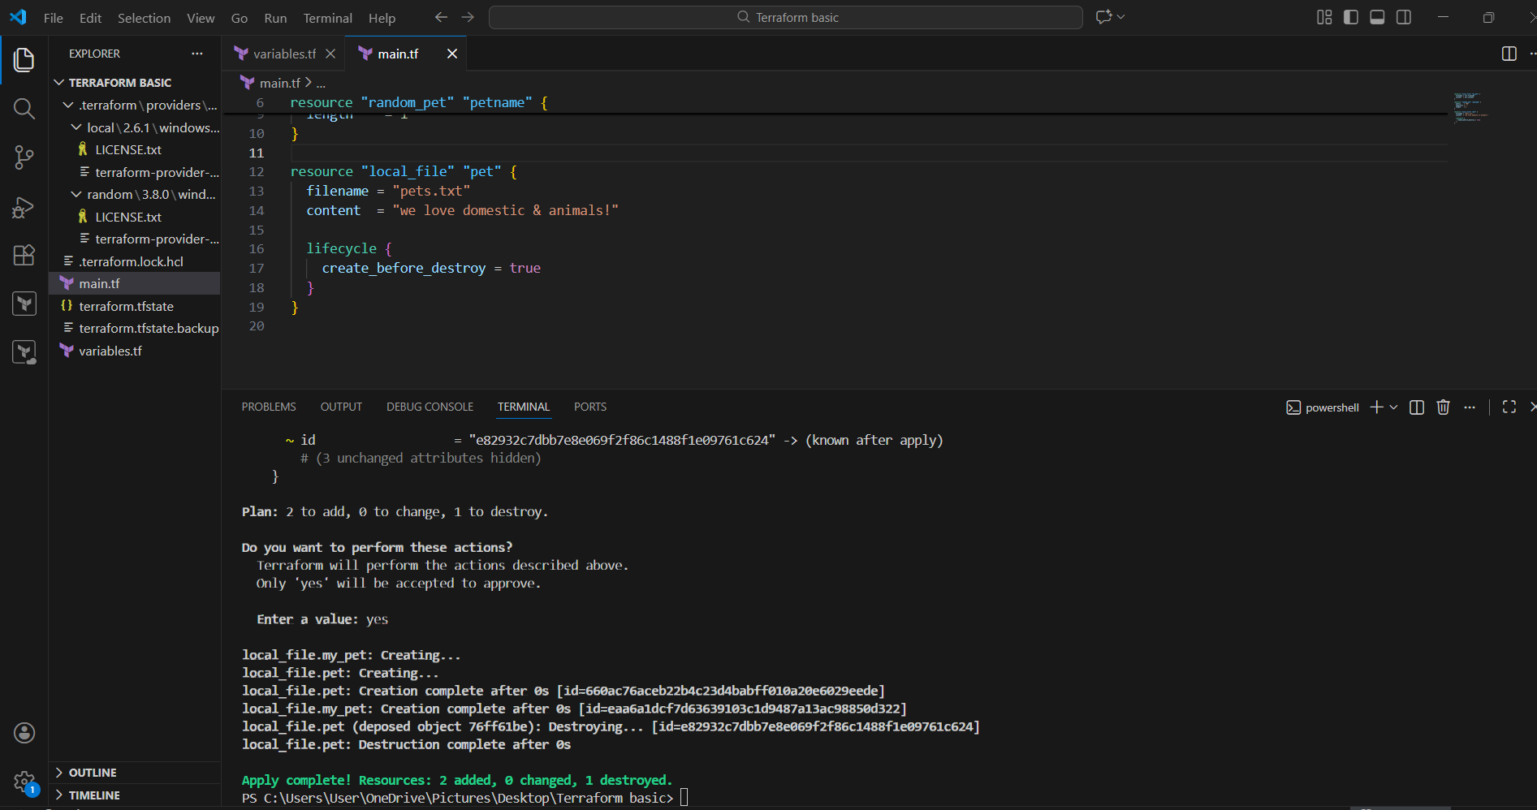
Step 15: Changed Content Again (Normal Behavior)
User updated content to:
content = "we love birds!"
Terraform detected:
- Content change
- Replacement required
Execution succeeded because create_before_destroy was enabled.
Step 16: Used prevent_destroy
User added prevent destroy protection:
resource "local_file" "pet" {
filename = "pets.txt"
content = "we love birds!"

lifecycle {
prevent_destroy = true
}
}
Purpose
- Protect the resource from accidental deletion

Step 17: Terraform Error Encountered
User ran:
terraform apply
Error Observed
Error: Instance cannot be destroyed
Resource local_file.pet has lifecycle.prevent_destroy set
Explanation
- Terraform planned to destroy the file
- prevent_destroy = true blocked the operation
- Terraform stopped execution to protect the resource
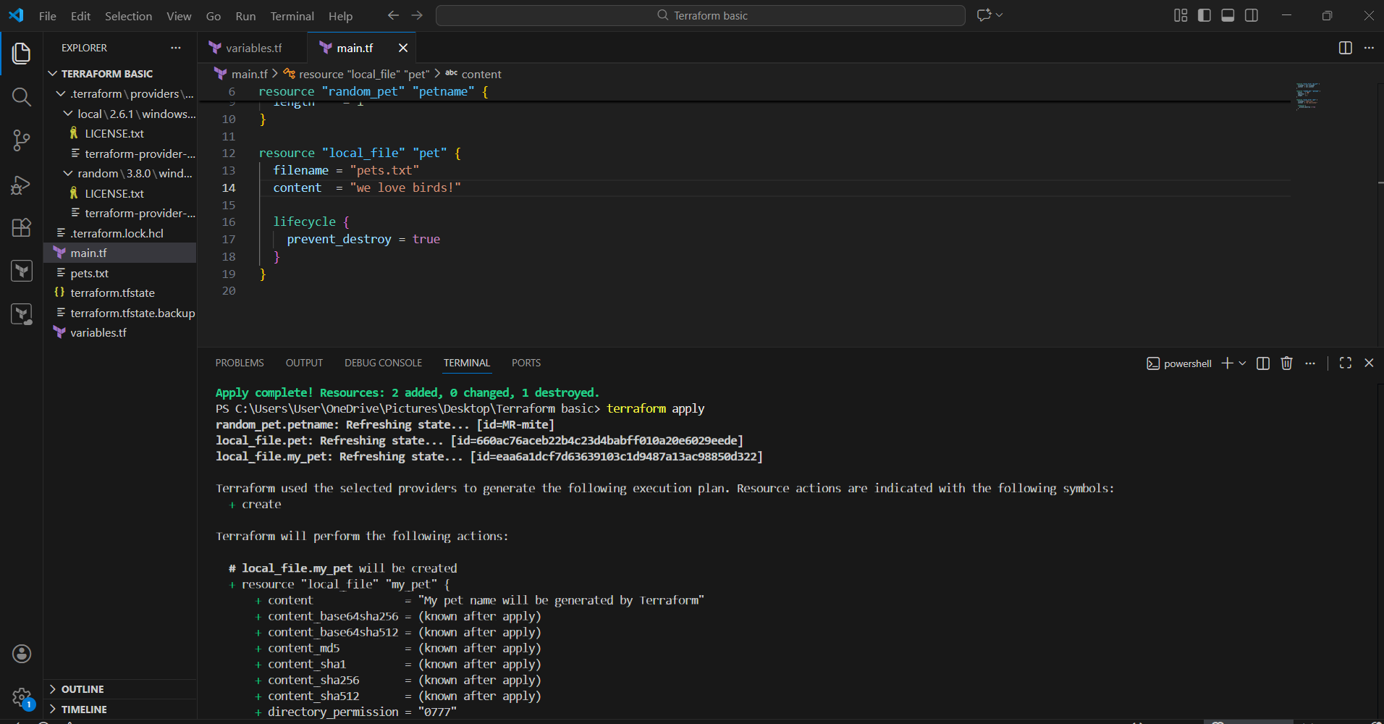
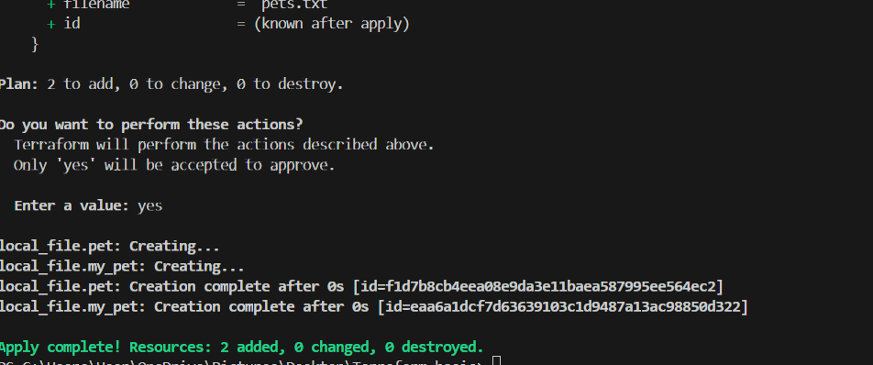
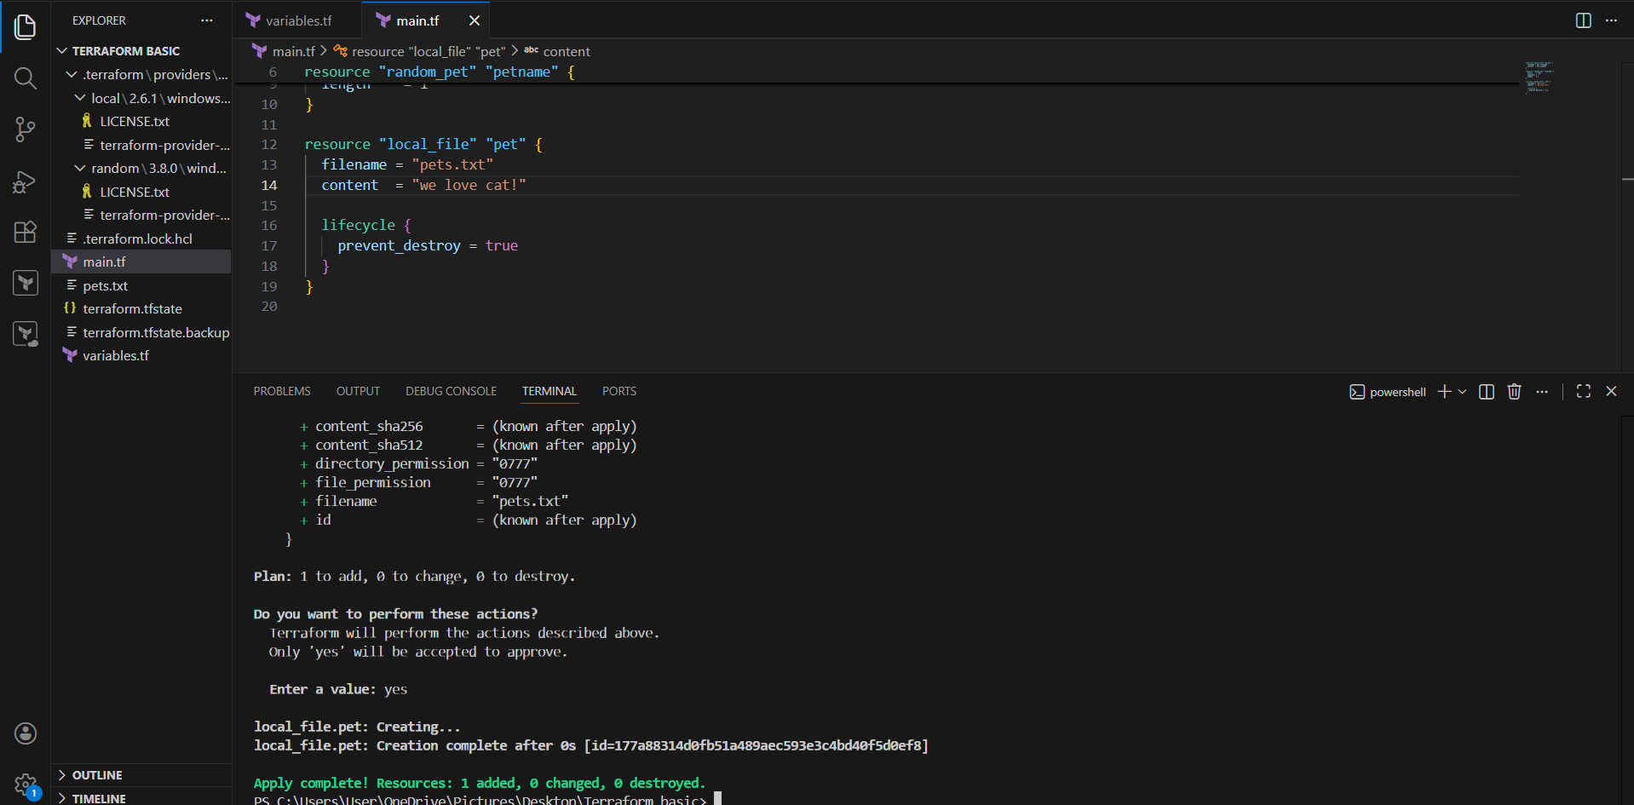
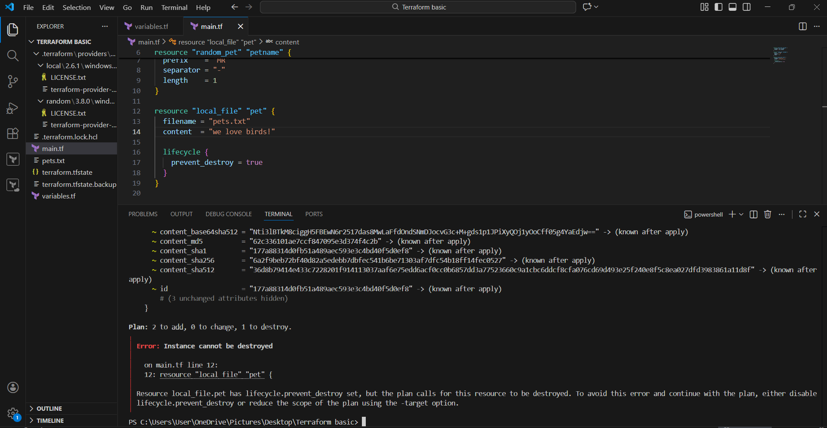
Step 18: Used ignore_changes
User replaced prevent_destroy with ignore_changes:
resource "local_file" "pet" {
filename = "pets.txt"
content = "we love birds!"

lifecycle {
ignore_changes = [content]
}
}
Purpose
- Tell Terraform to ignore content changes
- Prevent replacement when content is modified
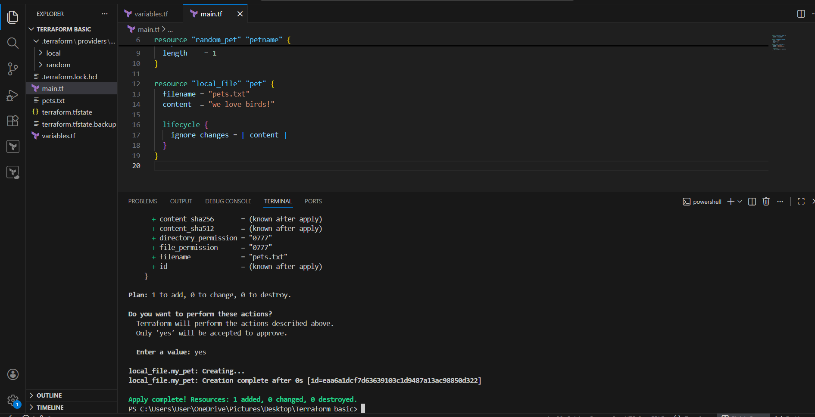
Step 19: Modified Content Again
User changed content to:
content = "we love dogs!"
Terraform Behavior
- Terraform ignored content change
- No destroy or recreate occurred
Result
Apply complete! Resources: 1 added, 0 changed, 0 destroyed
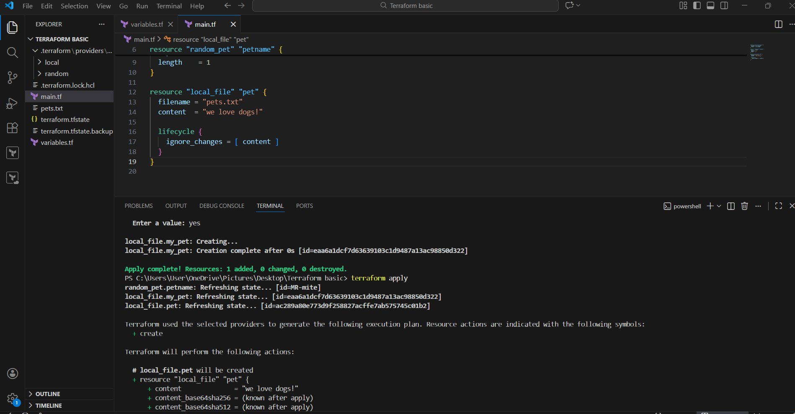
Step 20: Final Validation
- File pets.txt exists
- Terraform did not replace resource
- State file remains consistent
- Lifecycle rule worked as expected

Conclusion:
This continuation demonstrated how Terraform lifecycle meta-arguments control resource behaviour. The user successfully tested resource replacement, protection, and change-ignoring mechanisms, gaining a clear understanding of Terraforms lifecycle management capabilities.

Task Title
Integrating Terraform with Jenkins Using Terraform Plugin and Pipeline Script from SCM
Objective:
To integrate Terraform with Jenkins using the Terraform plugin, execute Terraform commands through a Jenkins pipeline, and validate successful execution with manual approval.
Prerequisites:
• Jenkins installed and running
• Git installed on Jenkins server
• Terraform Plugin installed in Jenkins
• GitHub repository containing Terraform code and Jenkinsfile
• Internet access to download Terraform and providers
Steps performed:
Step 1: Prepared Terraform Code in GitHub Repository
A GitHub repository was created containing the following files:
• Jenkinsfile
• main.tf
• providers.tf
• variables.tf
• README.md
Terraform resources used in the project:
• local_file
• random_pet
Step 2: Defined Terraform Providers (providers.tf)
Terraform providers were defined to use local and random resources.
The required provider versions were specified to ensure compatibility.
Step 3: Declared Variables (variables.tf)
Variables were created to make the Terraform configuration dynamic.
These include:
• File name
• File content
• Random pet prefix
• Separator
• Length
This allows changes without modifying the main Terraform code.
Step 4: Configured Terraform Tool in Jenkins
In Jenkins UI, the following steps were performed:
• Navigated to Manage Jenkins → Tools
• Clicked on Add Terraform
• Entered Name as: Terraform
• Enabled Install automatically
• Selected Terraform version (Linux amd64)
• Clicked Save
This configuration allows Jenkins to automatically install Terraform during pipeline execution.
Step 5: Created Jenkins Pipeline Job
• Clicked New Item in Jenkins
• Entered job name: Terraform Task-02
• Selected Pipeline
• Clicked OK
Step 6: Configured Pipeline Script from SCM
In job configuration:
• Selected Pipeline script from SCM
• Selected SCM as Git
• Provided Repository URL:
https://github.com/krishnav7090/terraform.sam.git
• Set Branch Specifier as: */main
• Set Script Path as: Jenkins file
• Enabled Lightweight checkout
• Clicked Save
Step 7: Jenkins file Used in Repository
The Jenkins file defined the pipeline stages as follows:
• Checkout source code from GitHub
• Terraform Init
• Terraform Plan
• Terraform Apply with manual approval
Terraform tool configured in Jenkins was referenced in the pipeline.
Step 8: Executed Jenkins Job
• Clicked Build Now
• Jenkins executed the following stages sequentially:
– Declarative Checkout SCM
– Terraform Tool Installation
– Checkout from SCM
– Terraform Init
– Terraform Plan
– Terraform Apply
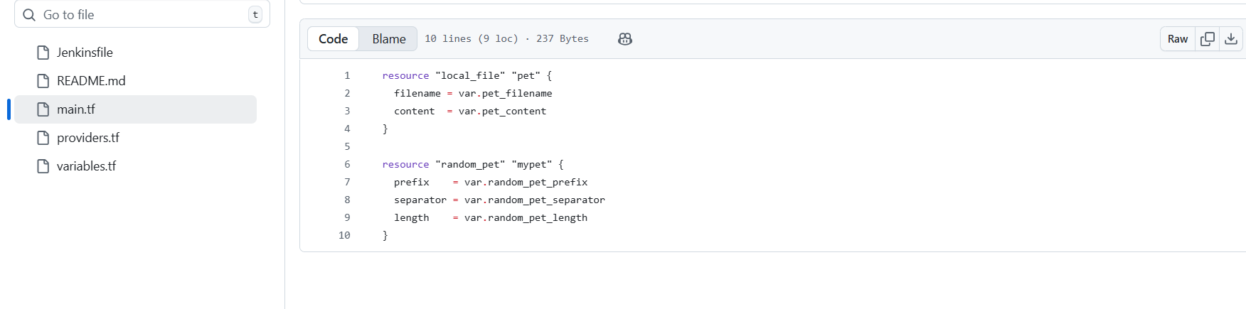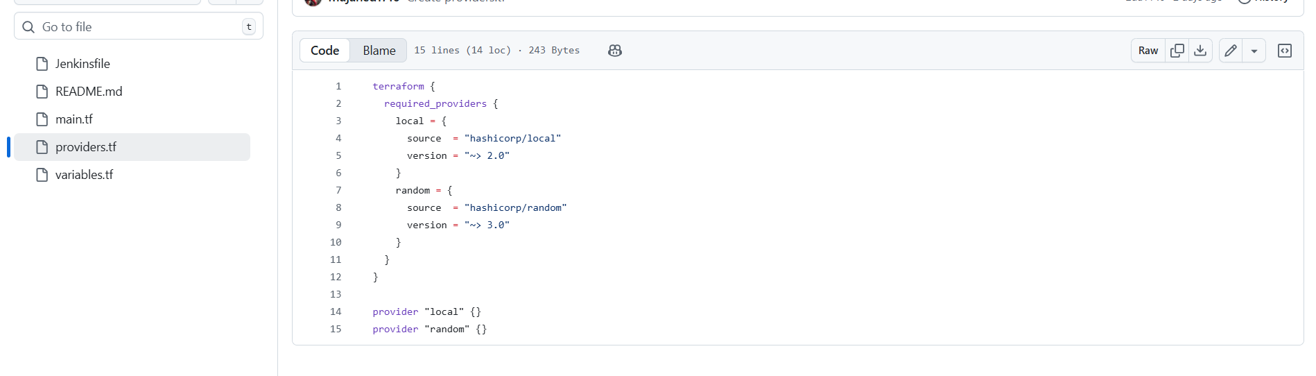
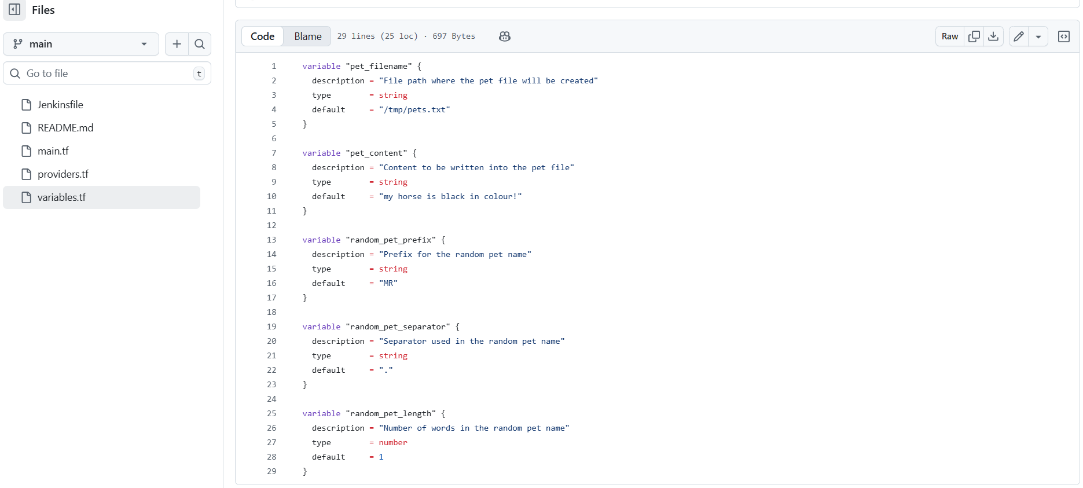
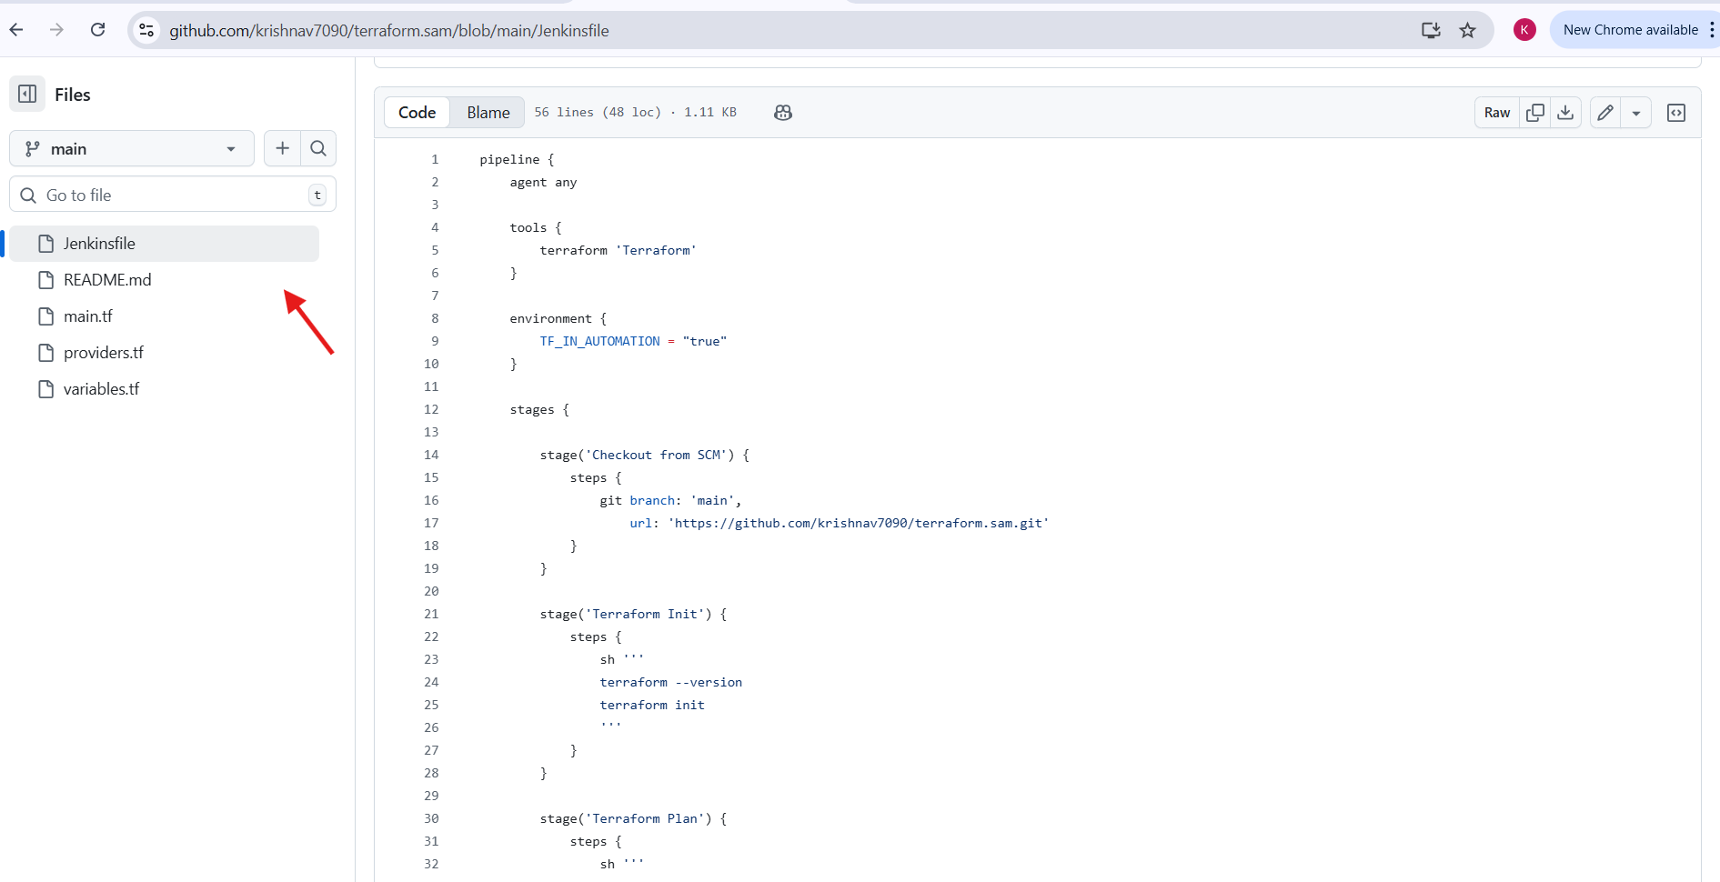
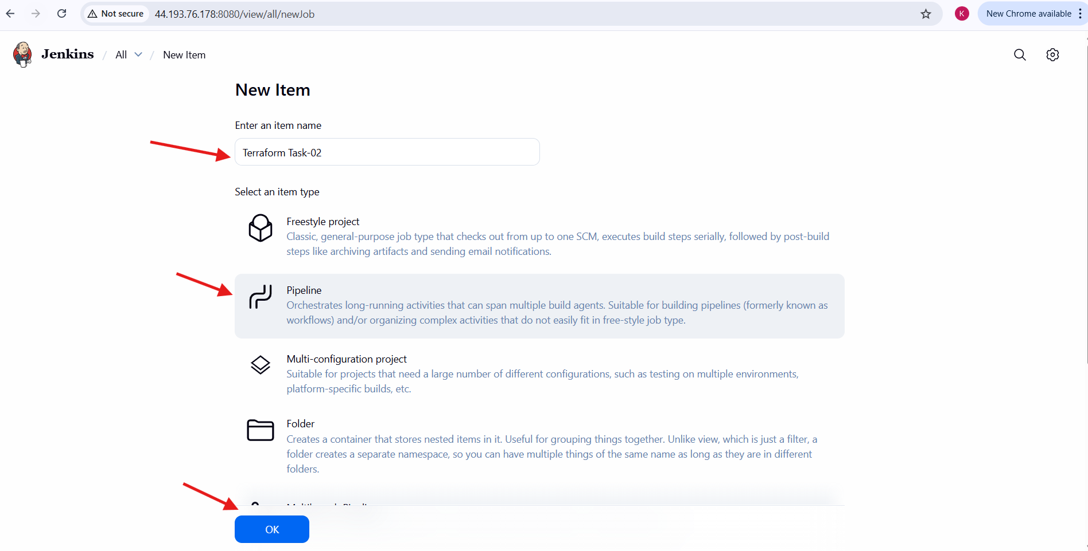
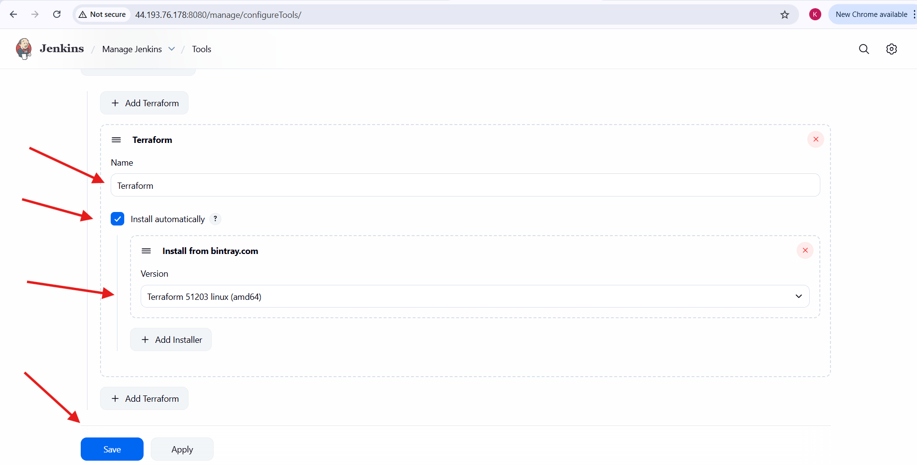
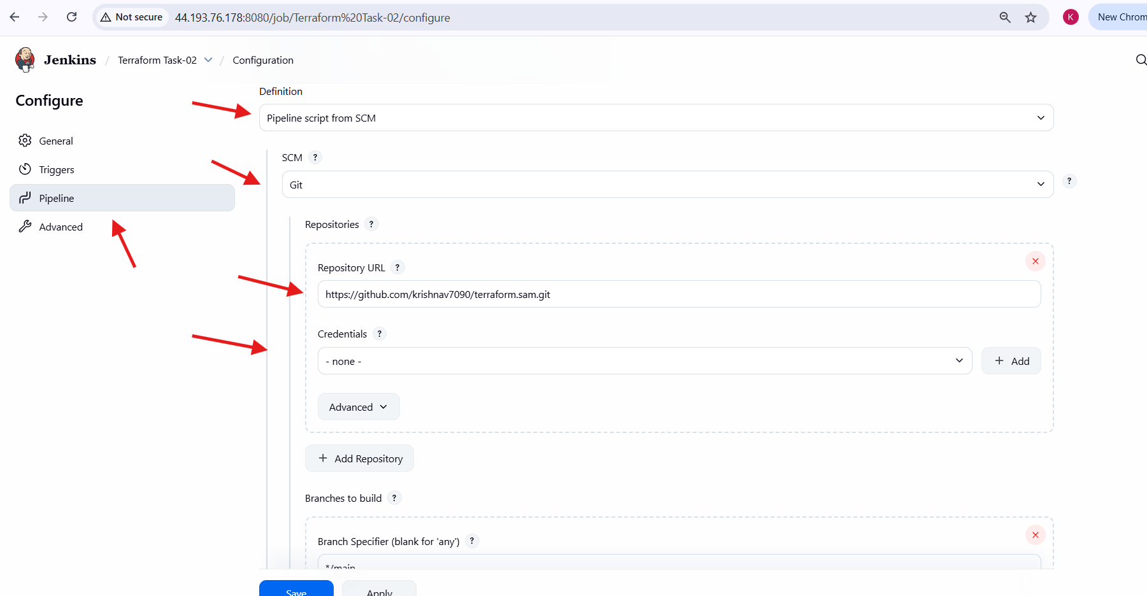
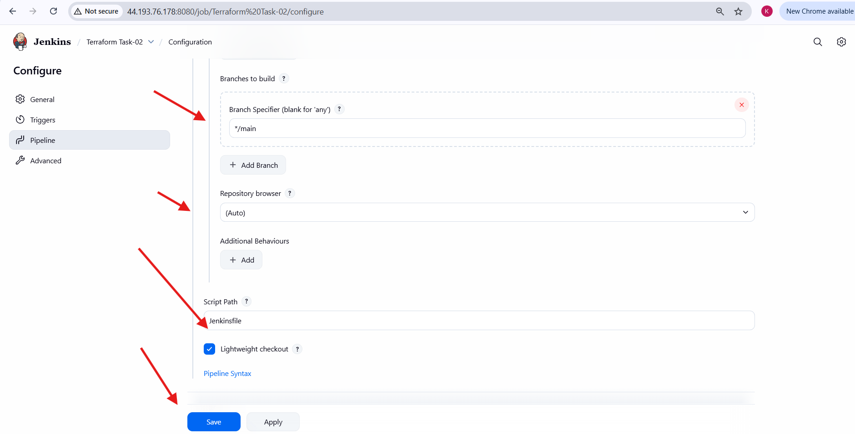
Step 9: Manual Approval for Terraform Apply
• Jenkins paused execution at Terraform Apply stage
• Approval message displayed: “Approve Terraform Apply?”
• Clicked Apply to continue execution
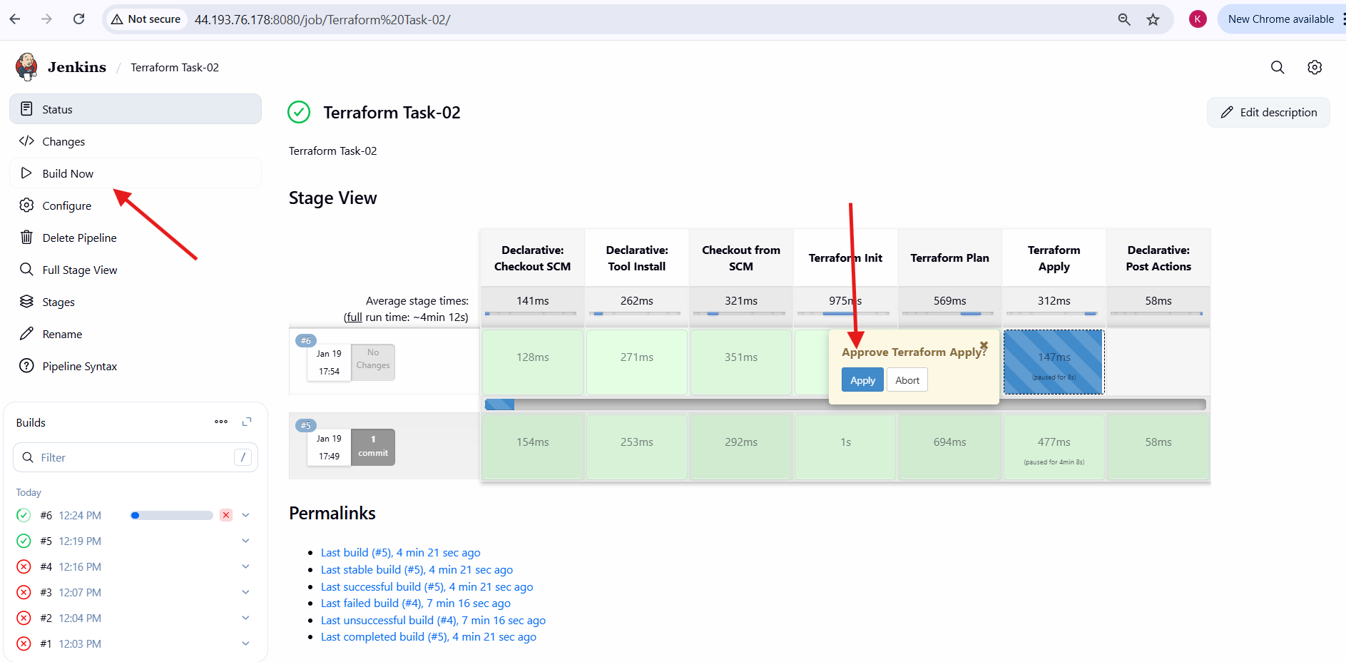
Step 10: Successful Pipeline Execution
• Terraform Apply completed successfully
• All pipeline stages turned green
• Jenkins job status displayed as SUCCESS
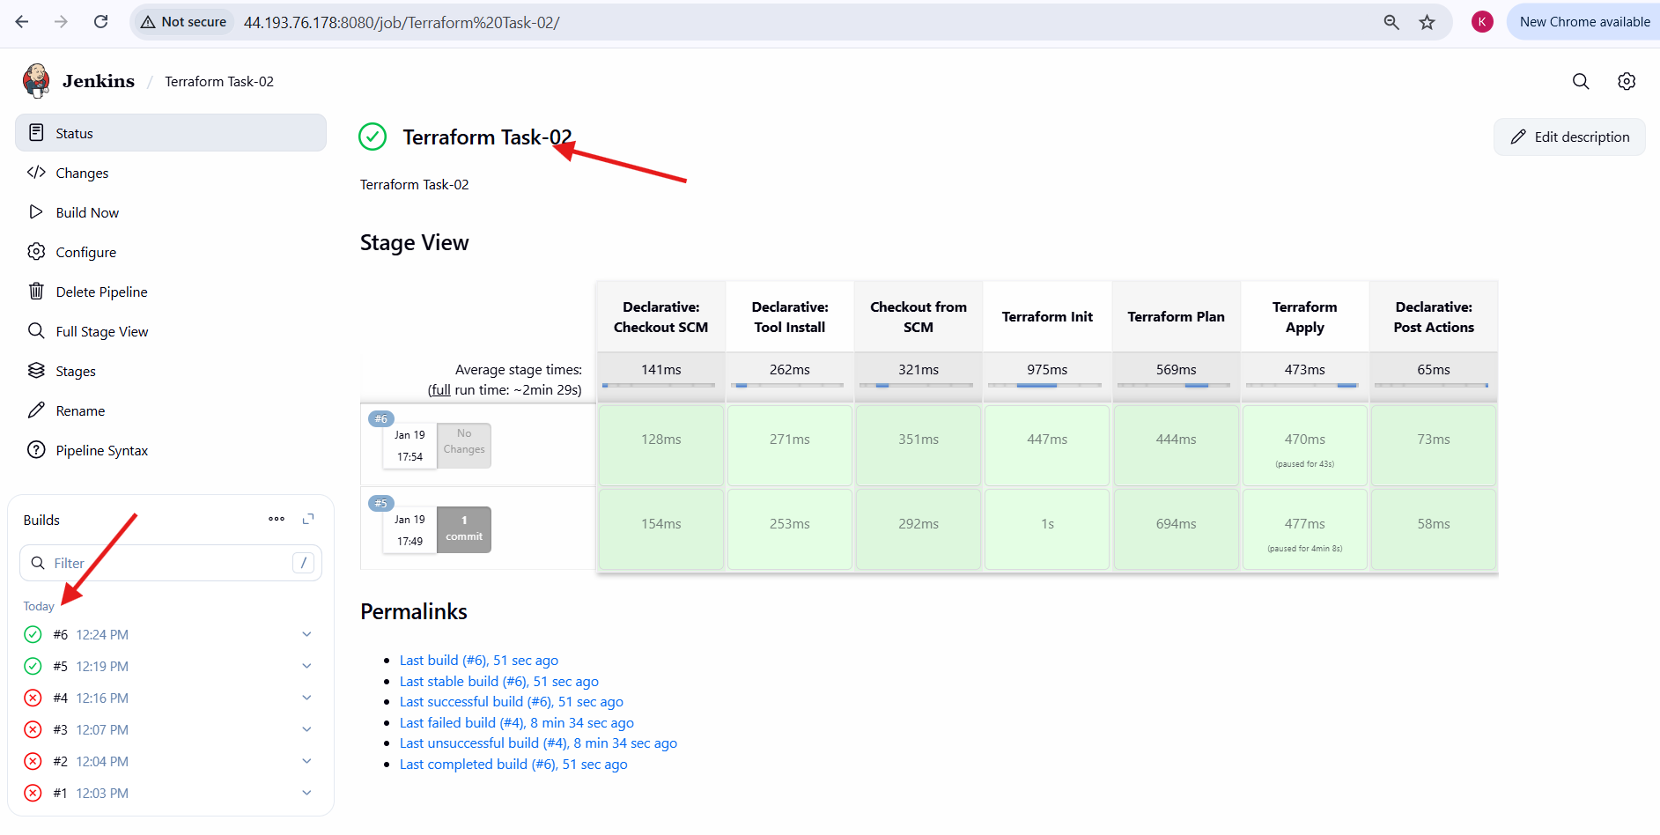
Validation Steps:
• Terraform was installed automatically by Jenkins
• Terraform Init executed without errors
• Terraform Plan generated execution plan
• Terraform Apply executed after approval
• Jenkins pipeline completed successfully
Issues faced:
• Initial failure due to incorrect Terraform command case
• Terraform command was corrected to lowercase
• Jenkins Terraform tool configuration resolved the issue
Conclusion:
Terraform was successfully integrated with Jenkins using the Terraform plugin and pipeline script from SCM. The pipeline executed Terraform Init, Plan, and Apply stages with manual approval, demonstrating a complete CI/CD workflow for Infrastructure as Code using Jenkins and Terraform.

